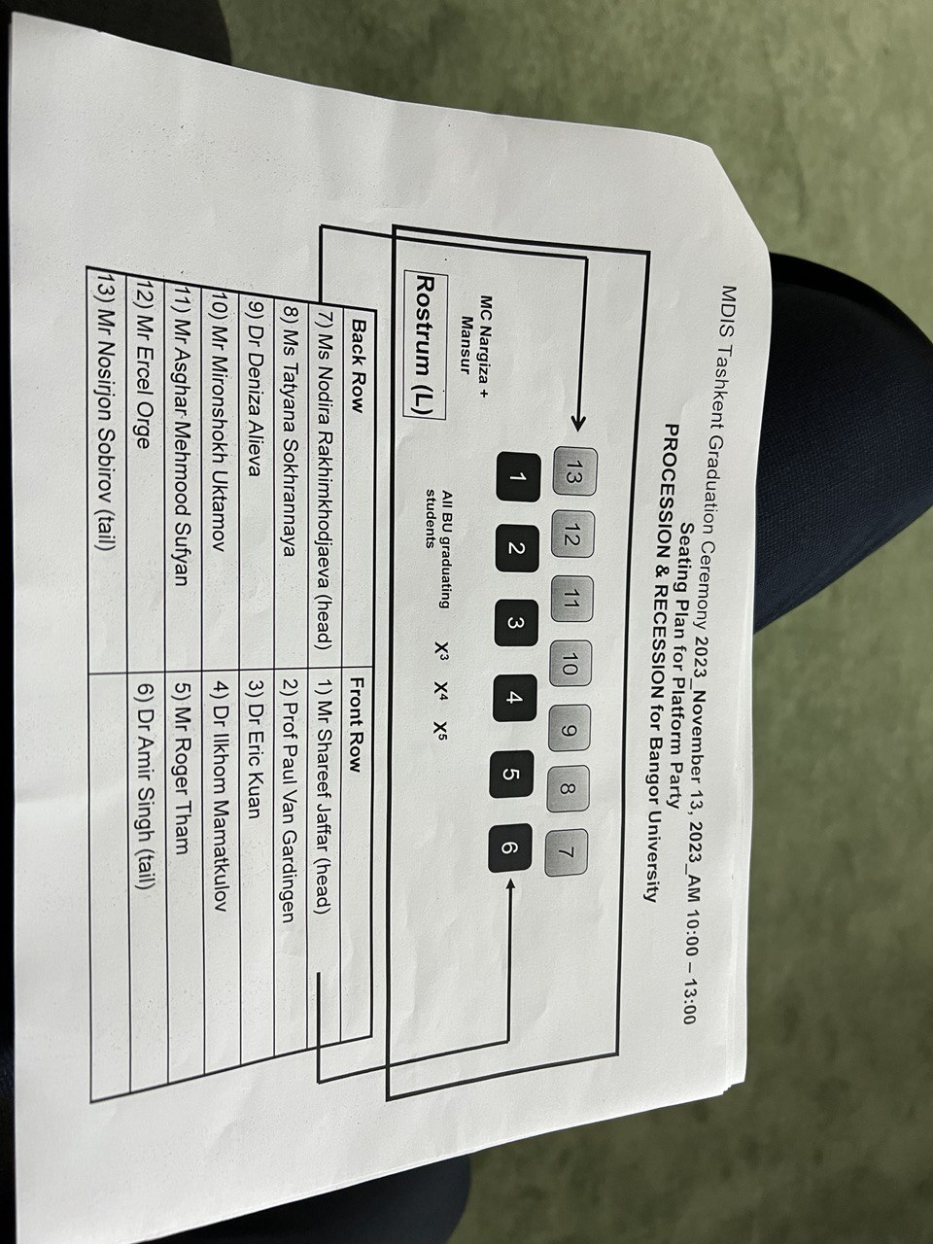

MDIS Tashkent Graduation Ceremony 15-16-17.10.2024
Seating Plan for Platform Party

12
4
5
6
3
2
1
10
11
13
9
8
7

